PD Session # 4: Strategies for Effective CBL Unit: Time Management and Student Grouping

Speaker: Ms. Debra Thompson, 6th Grade Teacher at Clermont North Eastern Middle School
Date: Wednesday, July 17, 2018
Time: 9:00- 11:00 am
Venue: University of Cincinnati, Swift Hall, Room 608

Prepared by:
Megan Stafford, Holmes High School, Covington, Kentucky
RET Participant for Project #2: “Energy Storage and Batteries”

This session was facilitated by Ms. Debra Thompson who has been teaching for 19 years. Over the last 3 years she has taught grades K, 2, 3, 4, and 6. For the last 12 years she has taught at Clermont North Eastern Middle School, and prior to that she taught in the West Clermont and Cincinnati Public Schools. She earned her undergraduate degree at NKU and her Master’s degree from Miami University, and most recently completed her participation as a member of Cohort 5 of the Cincinnati Engineering Enhanced Math and Science (CEEMS) Program.

As an experienced teacher who has implemented other Challenge Based Learning (CBL) units, Ms. Thompson started “Strategies for Effective CBL Unit: Time Management and Student Grouping” Skills Workshop with a discussion with RET Participants with their current concerns about CBL implementation. The main concerns brought forward by RET Participants during the discussion pertained to aligning standards, adequately providing preparation for AP and other standardized tests, and time management as it relates to the implementation of the CBL unit and related activities. To address strategies related to these concerns, Ms. Thompson used her PowerPoint presentation to provide a brief overview of several CBL units she previously implemented, as seen in Figure 1 below.

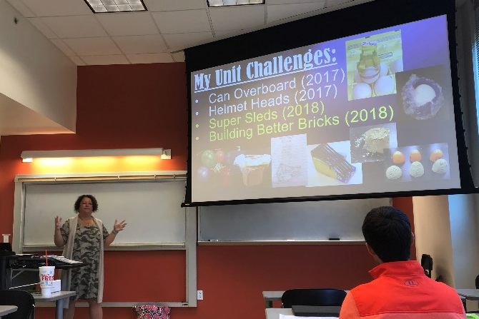  Figure 1: Examples of CBL Units | Figure 2: Teacher Checks

The first strategy Ms. Thompson provided was advising the use of graphic organizers. Graphic organizers can introduce the essential question and challenge and then follow the Engineering Design Process throughout the entire unit. The graphic organizer can also prompt students to maintain organization and stay on pace. Ms. Thompson provided examples of graphic organizers she has used for her CBL units. She also provided examples of completed graphic organizers to illustrate the importance of emphasizing the process versus the product when implementing CBL units.

Second, Ms. Thompson gave the advice of using teacher checks for all activities, graphic organizers, and challenges, as seen in Figure 2 above. Teacher checks have proven successful for pacing and to ensure all team members have partaken in the activity by evaluating various handwritings present on the graphic organizer. The teacher checks also provide real time formative assessments and break down projects into manageable assignments. These manageable assignments allow for student groups to work out problems together, while permitting for the teacher to stay in the facilitator role and create moments of success for the students.

The concern of time management was addressed by Ms. Thompson, as she emphasized the ability to be flexible should an activity not work. Integrating CBL challenges from day one, by doing a mini lesson at the beginning of the school year, was suggested to increase student engagement and understand time management before implementing an entire CBL unit. She cited several mini lesson examples such as the cup stacking challenge, the marshmallow launcher, and the marshmallow towers with spaghetti. These mini challenges could also be used before holiday breaks throughout the school year.

After giving suggestions for time management, Ms. Thompson transitioned into a discussion about think-pair-share and how to giving students ownership when working on CBL activities. She discussed how she gives her students ownership by remaining in the facilitator role and allowing the students to create the essential questions and challenge ideas. Student ownership can also be increased through the stimulating hook for the unit. Ideally the hook can increase engagement and ownership if it is relevant to the students’ lives. Furthermore, Ms. Thompson recommended increasing student ownership by giving the students opportunities to be the experts, gather their own information, and communicate their solutions in an active role within the classroom.

Another concern for CBL unit implementation is the grouping of students. Ms. Thompson gave time for another think-pair-share amongst the RET Participants to discuss current methods of student grouping. She then gave student grouping suggestions, as shown in Figure 3 below. Random grouping has proven most successful in her classroom but does not allow for student input. To account for this, she has modified her random grouping and has asked students to write on cards one student they work well with and one student they do not work well with, therefore increasing student input. She reported success with this method of student input and verbalized decreased complications within student groups.

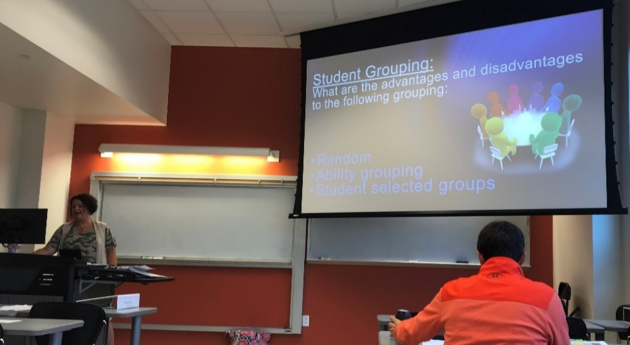
Figure 3: Student Grouping Discussion

Lastly she reviewed methods for conducting evaluations as part of the CBL unit implementation. Ms. Thompson evaluates the process by using a rubric to show the importance of the process and not just the product. Using a rubric to give a final evaluation has also allowed her to value mistakes and lead students toward identifying alternatives more authentically within her classroom. When the process and mistakes are valued the classroom culture can positively change.

As a summary of her presentation, Ms. Thompson provided the following suggestions for successful CBL unit implementation:
- Try the challenge before introducing to students
- Promote student ownership with thorough planning
- Plan for those who will finish early by providing extension projects
- Teacher checks – use graphic organizers
- Be flexible and reflect daily about how the challenge was implemented
- Communicate with resource teams, co-teachers, and other instructors at schools.

